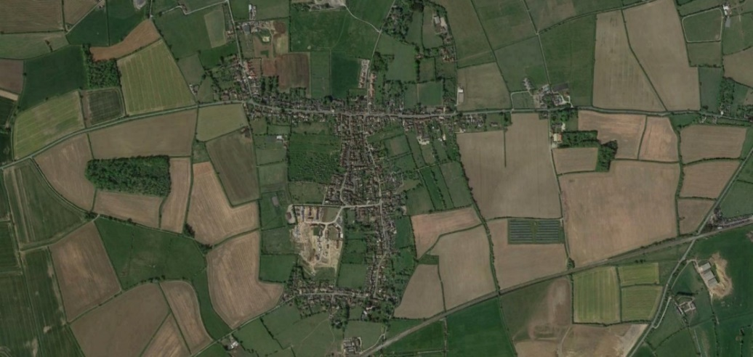  Keinton Mandeville Parish Council Newsletter  March 2024 |  | 
Parish Council Newsletter
Welcome to our first Parish Council Newsletter. This is very much an experimental publication to test it meets with the approval of you, as Keinton Mandeville residents. Because this is a test run, we have delivered it to all the households in the village – however our plan is not to do this again; we are working on producing four newsletters per year and, to minimise publishing costs they will only be available as follows;
A small number of hard copies available from Keinton Stores
As a download from the Parish Council website at www.keintonmandevillepc.org.uk
By email – to register your interest in receiving an email copy send your email address to kmpcclerk@gmail.com
We would very much like your feedback on any of the points above; and now for the news -

Grants made by Parish Council in 2023-24
The Parish Council enjoys providing grants to local organisations and to date this year have gone slightly over the budget allocation and given out grants totalling £7924. If you are involved in a local group that would benefit from a PC grant, please contact the Parish Clerk using the email provided at the end of the newsletter

Precept Request for 2024-25
In January, the Parish Council set their budget and confirmed that their precept request (request from the government) would be in the sum of £20 804 (it was £20 280 in 2023). This will result in a 6.5% increase per annum for Band D properties which be £43.80 (£41.13 in 2023). The Council have had to really consider carefully the amount requested due to the financial concerns expressed by Somerset Council on their ability to continue to provide non-statutory services. Parish Councils may have to pick up the cost of some services e.g. having bins emptied.

Traffic Report
The report commissioned by the Parish Council was drafted by the consultant and then a further request was made to look closely at pinch points in the village and this has now been completed. A verbal response from the consultant recommends that no further pressure is put onto Queen Steet in terms of traffic. The draft report has been discussed at the last two Parish Council meetings and members of the public can access these minutes on the website. The report has now been finalised and it is hoped it will be available for public release in April. The Parish Council will also hold a public consultation event to review the recommendations and receive views from the community before committing funding.

Heritage Trail
A leaflet has been produced which provides information about some of Keinton’s many heritage assets and suggests a walking tour that guides residents and visitors around these assets. Currently the leaflet is only in hard copy which will be distributed to residents with this newsletter and will also be made available electronically eventually.

Annual Parish Meeting 19 April 2024 at 7pm in the Village Hall
The main agenda for this meeting will be for the community to review the traffic report that was commissioned by the parish council and the recommendations that have been made. The finalised version of the report is now available on the parish council website using the following link
https://keintonmandevillepc.org.uk/Contents/ContentItems/46waqrc7czhf9xmeb33r3r01xr

Finally the parish council want to thank all those members of the community who clear up litter on a weekly basis and keep the village looking good.

Dates of forthcoming meetings: Details of the Annual Parish Meeting have been mentioned above. All other “routine” meetings commence at 7.30pm in the Village Hall. The first part of each meeting is a public session where anyone is welcome to raise an issue or ask questions.
The next three meetings are on April 2nd , May 7th and June 4th and the next newsletter will be published following the June meeting.

Keinton Environment Group
Keinton Community Copse - Our “Adopt a Tree” scheme should be available soon after the end of March; we hope this will get you involved in looking after your own little part of the Copse or just letting us know if you see a problem.
On 16th and 17th March volunteers were involved in wildflower planting at a number of sites around the village including the Parish Church, Methodist Church and some road verges. There’s still time to seed more areas before the dry weather of summer arrives so do let us know if you’d like to be involved or if you have a verge or other area you’d like to be re-wilded.
The trimming of the hedgerow on the south side of the access road to the Village Hall has been completed and was jointly funded by the Environment Group and the Parish Council.
Do contact us (or come to a meeting) if you would like advice on feeding and providing shelter for wildlife. Some of our members are skilful at constructing hedgehog, bat and bird boxes and would be delighted to pass their expertise on to you and your family.
Finally keep a look out for details of the KEG Environment Day On 15th June. There will be a number of local speakers, food, fun things for kids and a chance to calculate and work out how you might reduce your personal carbon footprint. We are also looking for nominations for the best “wild or eco-friendly” garden for an award to be presented at this event. Please send nominations or suggestions to KEG using one of the links below.
Our meetings are open to anyone to attend and we’d love to get more people involved in what we do. Meetings are held in the Quarry Inn on the second Wednesday of the month at 7.00 pm

Contact the Parish Council  Email: kmpcclerk@gmail.com  Website: www.keintonmandevillepc.org.uk | Contact the Environment Group  Facebook; (5) Keinton Environment Group (KEG) | Facebook  Email; info@keintonenvironmentgroup.org.uk

